# How To — Grafana Alerts on PagerDuty

Lets Assume you have been able to follow the tutorial below to set up your own Grafana Dashboard, we are going to cover in this article how to set up notification channels, PagerDuty, that you can send your Grafana alerts to Email

**Some parameters are crucial for a Validator, such as the % of blocks that the node is voting on (a too low % would induce slashing for the Validators and his Delegators), or ones that are related to the system health (uptime, disk space, cpu/ram usage…).**

Now, considering the responsiveness expected from Validators nodes’ admins (few hours), receiving these alerts by email may not be sufficient to draw their attention in due time, hence the need for more advanced notification channels.

Below are the Steps :

**STEP 1: Set up a notification channel on PagerDuty**

* Sign-in on your computer with that account.
* Stick to the Free Plan, it should be enough for what you need.

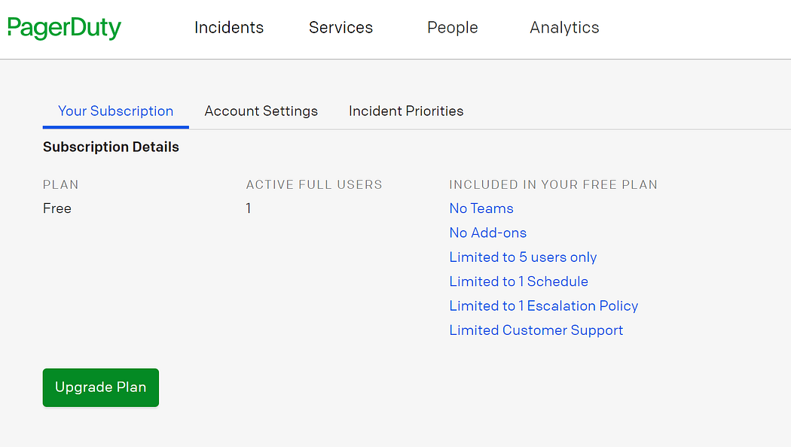

* Click on your profile name on the top right hand corner and click to “My Profile”
* Set up your emails and Test the mobile notifications.
* Go to Configuration > Escalation policies and make sure to include reminders to your notifications as per the print screen below.
* Don’t forget to repeat the policy X times, otherwise the notification will appear only once on your phone with no reminder.
* Come back to the Home Page and in the Services section, click on New Service
* Give the service a name. For Grafana, choose: “Use our API directly”.
* Once created, you will find your Integration Key in the settings of your new Service.
* Come back to the Home Page and in the Services section, click on New Service.
* Give the service a name. For Grafana, choose: “Use our API directly”.
* Once created, you will find your Integration Key in the settings of your new Service.

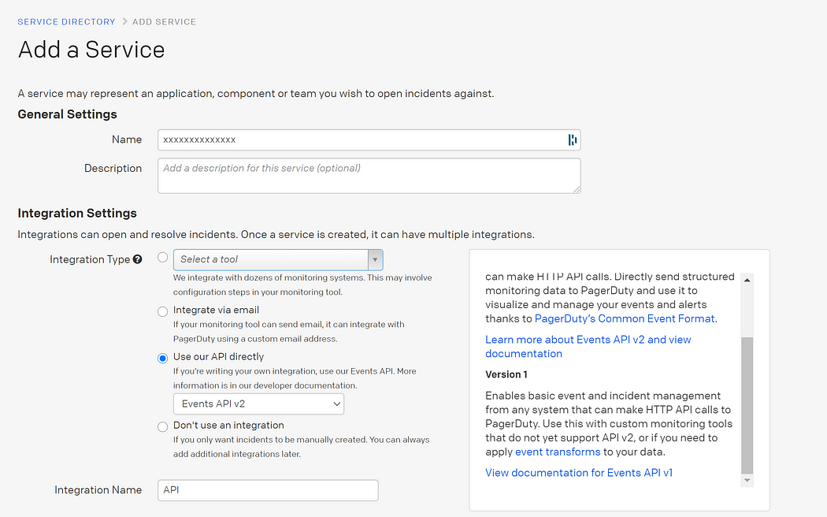

Give it a name. For Grafana, choose “Use our API directly”.

Once created, you will find your Integration Key in the settings of your new Service.

* Login to grafana
* Click to the left Bell icon
* Add notification channel
* Select PagerDuty and the options you prefer.
* Choose a name for the channel and paste your Integration Key in the field.
* Click on Send Test. If everything went well, you should receive notifications on your phone app and email address.

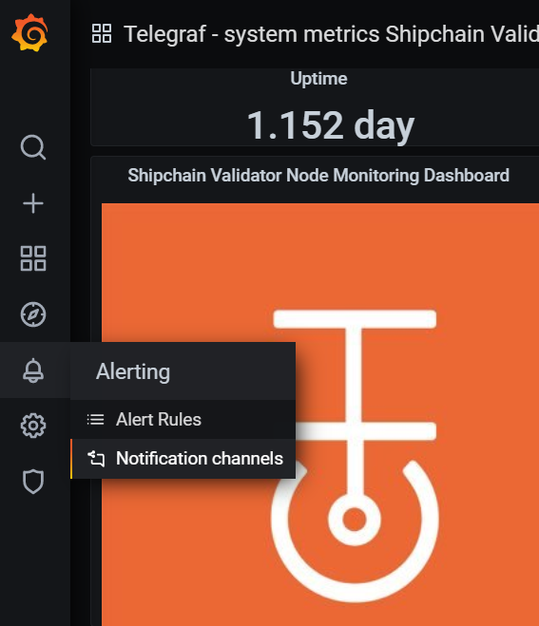

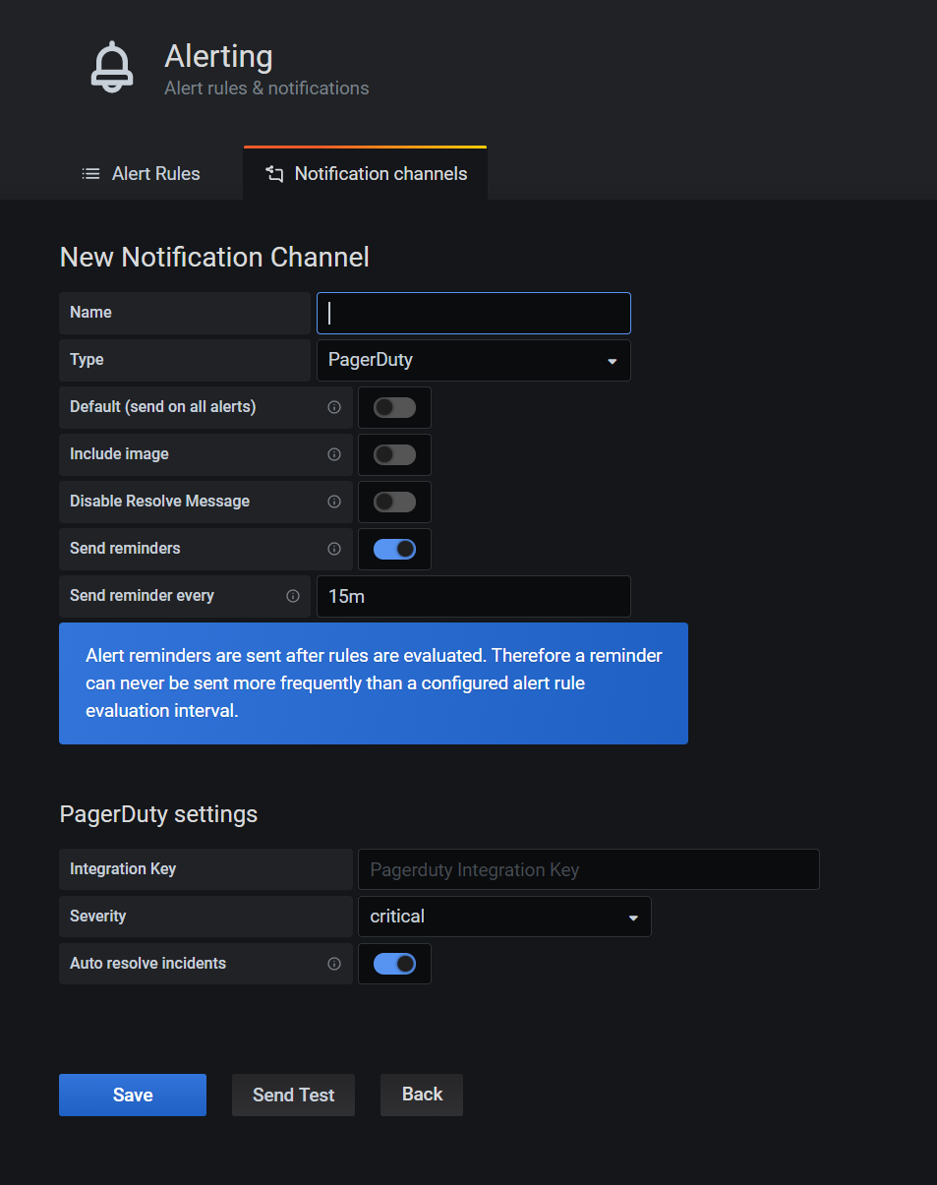

**Create your Grafana Alerts**

* Please be aware that you can only set Alerts on Grafana on Charts/Graphs.
* You will find the screen below after a right click on the chart > Edits
* Go the Alert section, create a new Alert and set it up as per the print screen below.
* This alert below will calculate every minute the average CPU load of the Query A and raise an alert if the load is above 80%. It will also raise an alert if the variable is not responding at all (important for shipchain related variables).
* You can chose as many Send To Notifications channels as you have set up before.

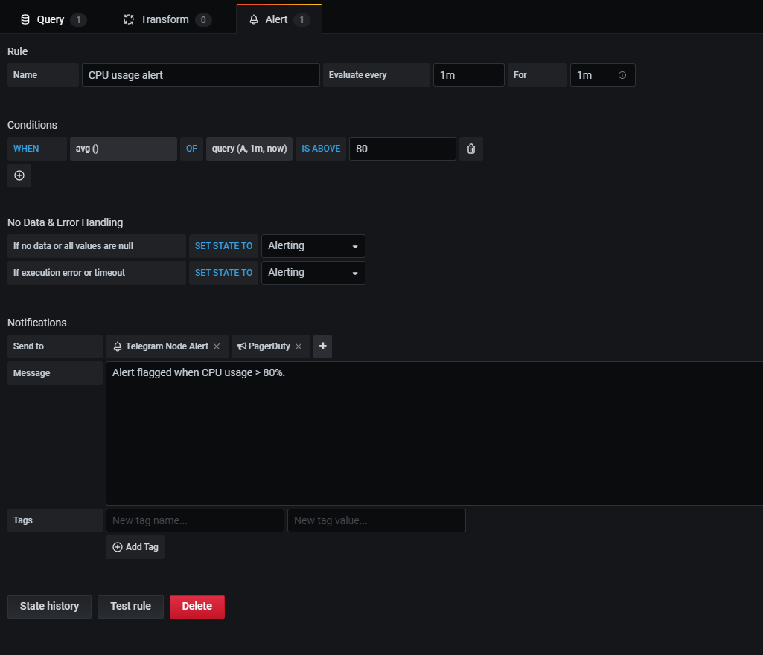

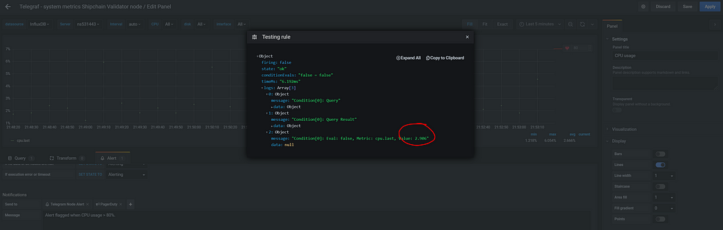

It is good practice to try “Test rule” and see if the variable is different to (null).

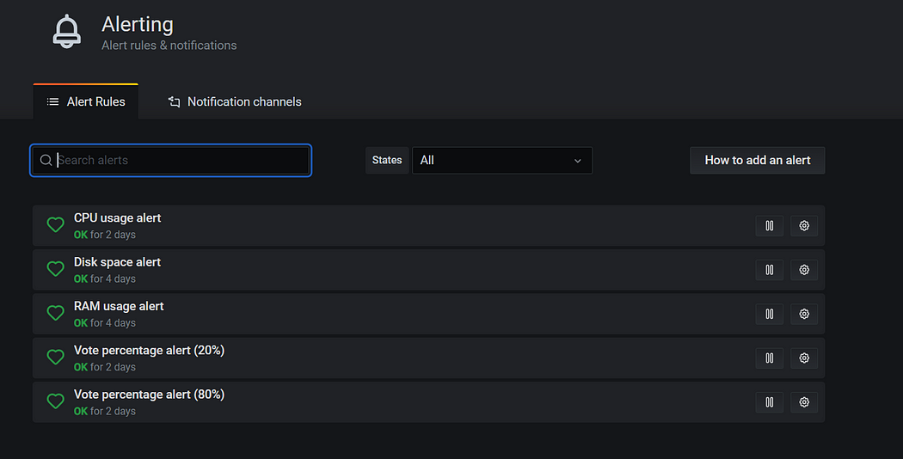

Here are all the alerts I have set up on my node. Vote percentage < 80% is worth being notified of but the real critical one is the one < 20% when slashing could occur.

**STEP 5: Wake up in the middle of the night!**

* You can see below some examples of what push notifications from PagerDuty and via email will look like.
* We can integrate this with team and Slack as per the requirement we just need to make sure to have relevant plugins in place.

